SVG Fill on Scroll (Stroke filling)

Intro to SVGs. Why use SVGs.

Steps:

\*Get excited, this is what we are gonna build! Insert live link and image\*

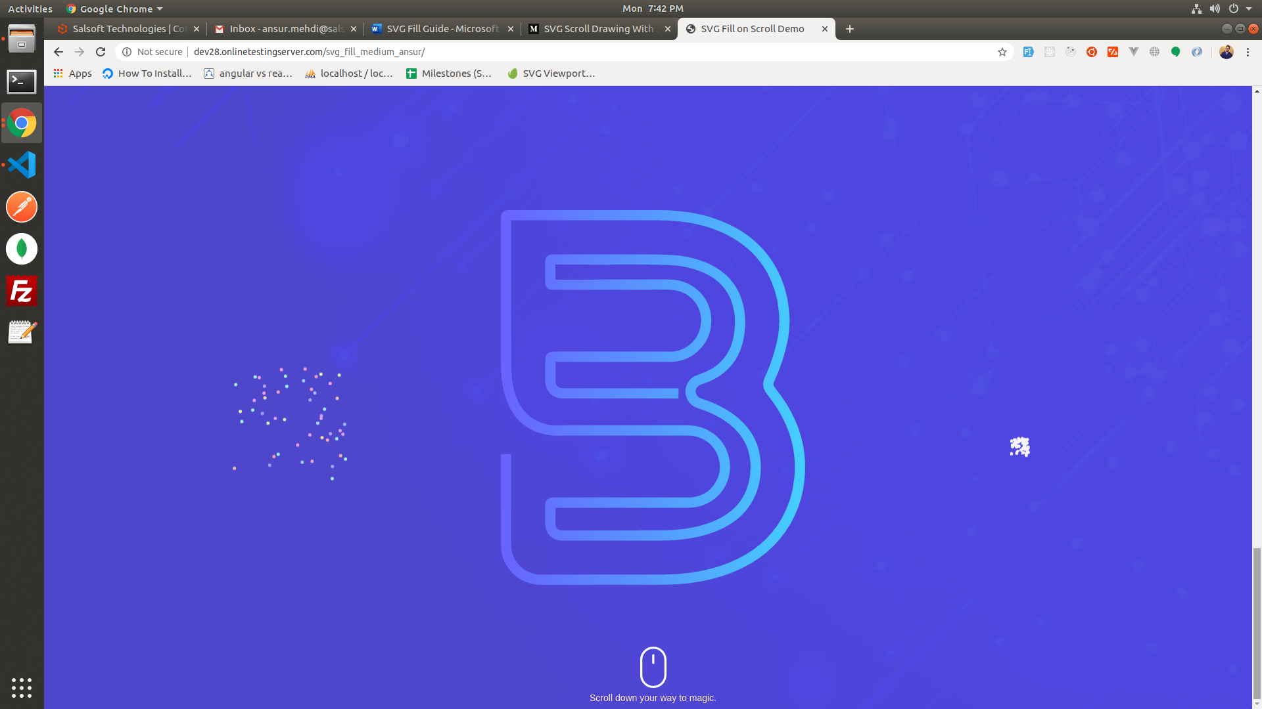

\*HTML and CSS\*

1. Get an SVG with path attribute. (show our SVG image here)

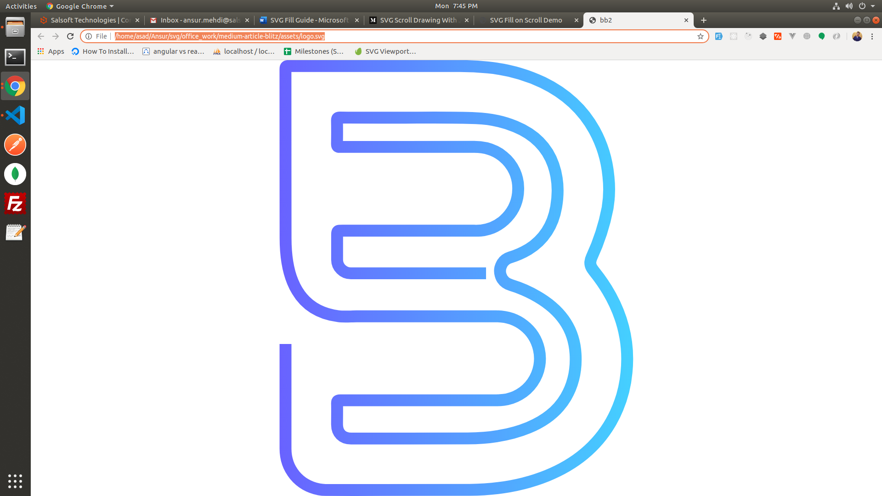

1. Wrap SVG in div, let’s say “svgDiv”.
2. Wrap svgDiv in another div, let’s say parent div

and give it some height to get a vertical scroll.

1. Set stroke, fill, stroke-width and id on the svg.
2. Set the position attribute on svgDiv to fixed, so that

It always stays on the center of screen.

\*JavaScript\*

1. Get length of the svg (show snippet part).



1. Assign *strokeDashArray* and *strokeDashOffset* to

svg through code. The most important part as it is

responsible for the filling of stroke in SVG.

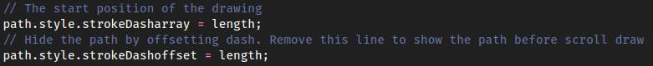

1. Add event listener to window scroll, and find the scrollpercentage (done through JS code snippet), set the offset equal to

offset = pathLength – scrollpercentage

1. Gradually the offset decreases from pathlength to 0, giving a fill effect.

(code snippet)

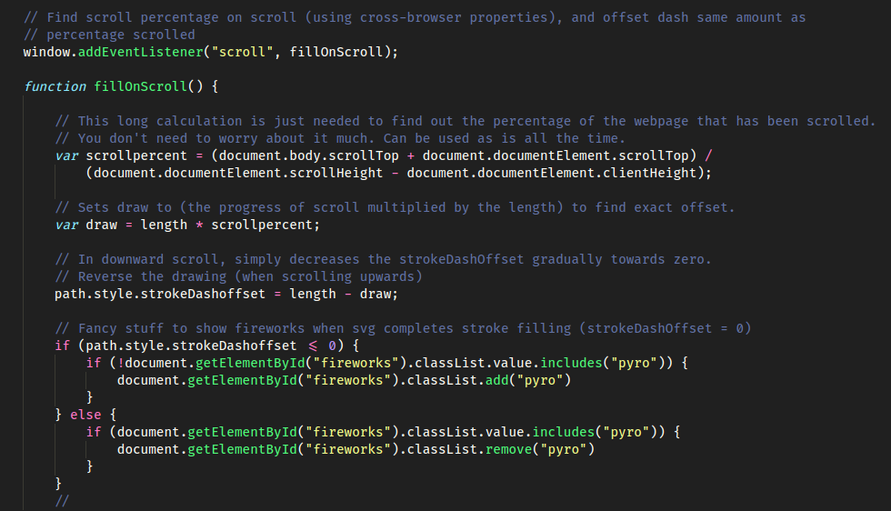

Congrats! You have hopefully learnt how to fill svg on scroll.